Supporting information

Supplementary Table 1. Breakdown of subjects by centres
 | Total count | Percentage (%)
UCL | 268 | 34.9
ULB | 90 | 11.7
IGG | 23 | 3.0
EKUT | 72 | 9.4
SEIN | 54 | 7.0
UKB | 2 | 0.3
RCSI | 188 | 24.5
BHSCT | 4 | 0.5
UMCU | 3 | 0.4
ULIV | 63 | 8.2

Supplementary Figure 1. Distribution of AED start dates
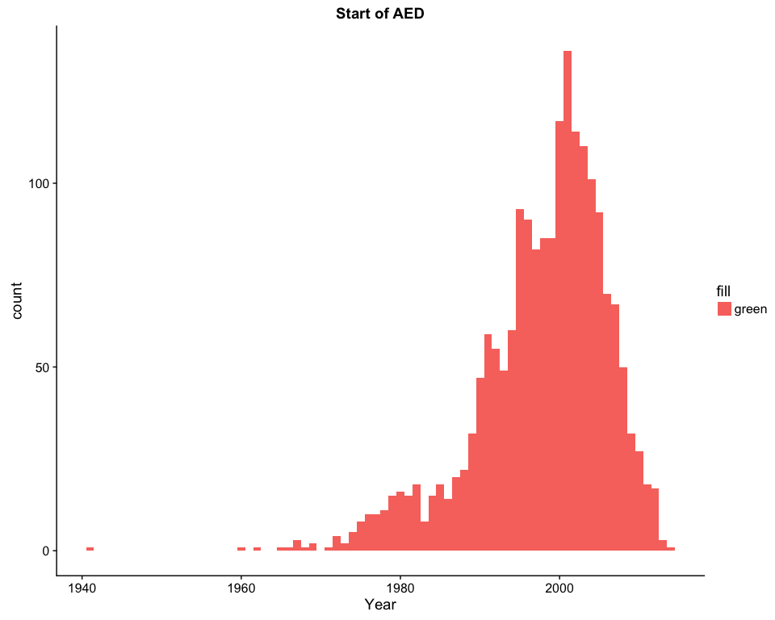

Supplementary Figure 2. AED treatment duration.
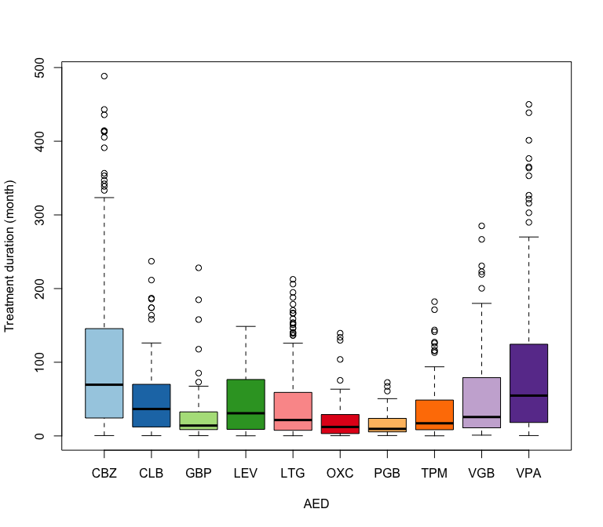

Supplementary Table 2. Order of AED use
AED | N 1 | N 2 | N 3 | N 4 | N 5 | N 6 | N 7 | N 8 | N 9 | N 10
CBZ | 29.2 | 22.4 | 15.7 | 10.6 | 8.5 | 5.6 | 2.6 | 1.9 | 1.8 | 1.8
CLB | 7.1 | 12.0 | 10.2 | 11.7 | 11.7 | 10.8 | 8.6 | 8.6 | 5.5 | 13.8
GBP | 8.1 | 9.4 | 12.6 | 15.7 | 13.9 | 9.0 | 12.1 | 7.2 | 4.0 | 8.1
LEV | 4.6 | 8.4 | 14.3 | 11.4 | 13.9 | 11.0 | 10.2 | 10.5 | 5.7 | 10.0
LTG | 9.9 | 14.5 | 16.9 | 16.0 | 11.3 | 12.4 | 7.7 | 5.2 | 2.8 | 3.3
OXC | 6.9 | 11.1 | 10.6 | 11.6 | 9.5 | 10.1 | 11.1 | 7.4 | 5.8 | 15.9
PGB | 1.6 | 6.3 | 4.7 | 6.3 | 7.1 | 10.2 | 7.9 | 14.2 | 15.7 | 26.0
TPM | 5.6 | 8.7 | 9.2 | 11.0 | 13.3 | 15.6 | 12.0 | 9.7 | 6.4 | 8.7
VGB | 3.7 | 13.0 | 13.0 | 14.9 | 18.2 | 14.5 | 10.0 | 5.6 | 4.5 | 2.6
VPA | 24.0 | 18.7 | 18.4 | 14.6 | 10.6 | 3.6 | 4.7 | 2.3 | 0.9 | 2.2

Supplementary Figure 3. Frequencies of patients' age distribution
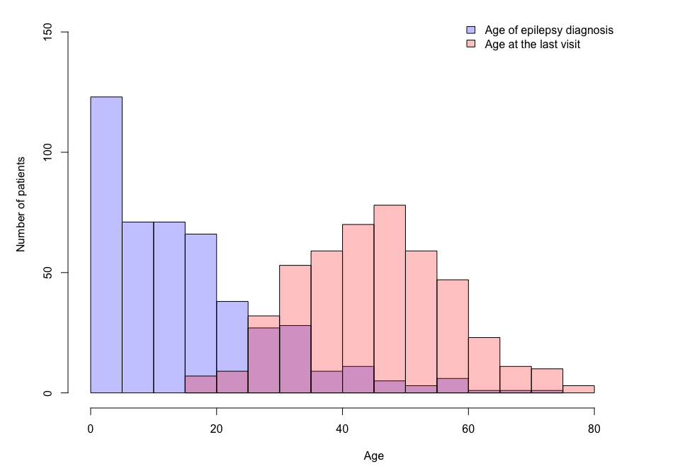

Supplementary Table 3. Reasons for AED discontinuation
AED | ADR | Both efficacy and ADR | Lack of efficacy | Other | Remission | Unknown
CBZ | 56 | 11 | 122 | 43 | 17 | 235
CLB | 8 | 1 | 35 | 17 | 2 | 108
GBP | 10 | 5 | 63 | 7 | 2 | 93
LEV | 43 | 24 | 64 | 35 | 3 | 98
LTG | 56 | 10 | 103 | 20 | 2 | 157
OXC | 31 | 8 | 29 | 8 | 3 | 31
PGB | 9 | 5 | 20 | 3 | NA | 24
TPM | 57 | 26 | 77 | 26 | 1 | 109
VGB | 24 | 6 | 66 | 14 | 5 | 114
VPA | 39 | 28 | 119 | 37 | 16 | 214

